**FINDINGS OF FACT AND DECISION**

**Case Number:** 274415

**Student’s Name:** REDACTED

**School District:** REDACTED

**Impartial Hearing Officer:** Hannah Schwager, Esq.

**Date of Filing:** June 4, 2024

**Hearing Requested by:** Parent

**Date(s) of Hearing:** November 15, 2024

**Record Close Date:** December 17, 2024

**Date of Decision:** December 17, 2024

**Names and Titles of Persons Who Appeared November 15, 2024**

**For the Student**

Parent Representative

Educational Director, Provider Agency

**For the New York City Department of Education**

District Representative

**BACKGROUND**

The Parent, through counsel, filed a Due Process Complaint (DPC) on June 4, 2024. In the DPC, the Parent alleges that the New York City Department of Education (DOE or District) failed to implement recommended special education services for the Student for the 2023-2024 school year (Parent Exhibit (P. Ex.) A). Parent is seeking an order directing the District to directly fund and/or reimburse the cost of private Special Education Teacher Support Services (SETSS) provided to the Student for the 2023-2024 school year (P. Ex. A, *see also* Transcript of Due Process Hearing 11/15/2024[1]). The Parent is also seeking a bank of compensatory hours for Occupational Therapy (OT) services which the Parent alleges were never implemented for the Student (Id.). As more fully discussed below, I find that the DOE failed to implement the Student’s recommended services, thereby denying the Student a free appropriate public education (FAPE) on an equitable basis for the 2023-2024 school year, and that the relief Parent seeks is appropriate.

**PROCEDURAL HISTORY**

I was appointed as Impartial Hearing Officer (IHO) on June 6, 2024. This case was originally scheduled to be heard as part of an omnibus docket and an off-the-record status conference was held on June 20, 2024. On September 19, 2024, the District submitted a motion to dismiss (MTD) based on a lack of jurisdiction. A due process hearing was held on November 15, 2024. At the hearing, I entered the MTD into the record as an IHO Exhibit and I allowed the Parent Representative to respond to the MTD. I also allowed the District Representative to supplement the District’s position (*see* Transcript of Due Process Hearing 11/15/2024). I reserved decision on the MTD.

Both parties offered exhibits into the record which were admitted into evidence. A complete list of all exhibits entered into the record at hearing is attached here as Appendix A. The parties made opening statements after which the District rested. Parent’s evidence included the affidavit testimony of the Educational Director of the Provider Agency who was cross-examined by the District Representative (P. Ex. G). Following cross-examination, the Parent rested, the parties made closing statements, and the hearing was concluded.

**FINDINGS OF FACT AND DECISION**

After a full review of the record generated at hearing, I make the following findings of fact and determinations.

It is uncontested that the Student and Parent reside in New York City and the Student attended a nonpublic school during the 2023-2024 school year. The Student is 16 years old and is classified as a student with a Speech or Language Impairment (P. Ex. B-1). In June 2020, an Individualized Education Services Program (IESP) was developed for the Student, with a projected implementation date of September 8, 2020 (P. Ex. B-1).[2] That IESP recommended the following services (P. Ex. B-8):

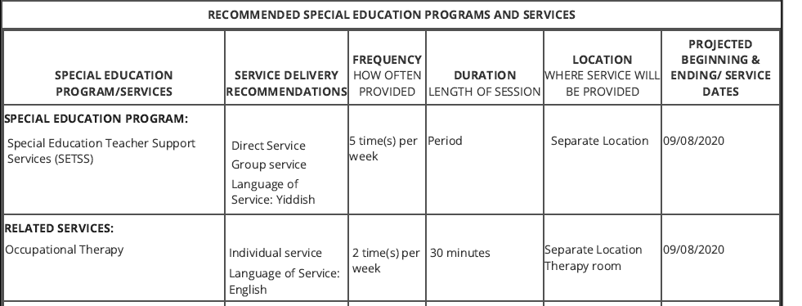

In August 2023, the Parent signed a contract with the Provider Agency for the provision of services to the Student for the 2023-2024 school year (P. Ex. D). The record shows that the Provider Agency charges $195.00 per hour for SETSS and began administering services to the Student at the beginning of the 2023-2024 10-month school year (P. Ex. D, see Transcript of Due Process Hearing 11/15/2024).

**I. Motion to Dismiss**

In the District’s motion to dismiss, the DOE asserted that the IHO does not have subject matter jurisdiction over the claims asserted in the DPC and argued that therefore the claims should be dismissed (IHO Ex. I-2). Specifically, the MTD argues that New York Education Law §3602-c does not grant the Parent the right to a file a DPC to request an enhanced rate for services (IHO Ex. I-3). The District argues that this right has never existed (Id.).

The District’s argument that Education Law § 3602-c and § 4404 do not provide subject matter jurisdiction is unsupported by law, and unavailing.   The new regulation’s plain language states that it applies prospectively to DPCs filed on or after July 16, 2024. The District Representative referenced guidance from the New York State Education Department (NYSED), indicating that the Education Law has never provided OATH with subject matter jurisdiction to hear requests for enhanced rate for equitable services. However, I decline to follow this guidance as it contravenes the rules of statutory construction that when amending a statute (or regulation), “amendments [ ] are presumed to have prospective application unless the Legislature’s preference for retroactivity is explicitly stated or clearly indicated.”[3] This is because a retroactive statute [or regulation] “would impair rights a party possessed when he [she] acted…thus impacting substantive rights.[4] Here, the plain wording of the regulation explicitly applies *prospectively* only. Therefore, even if I were to find that the MTD was ripe despite being filed prior to the new regulation being enacted, I would still find that such regulation is not applicable to this matter, where the DPC was filed well before July 16, 2024.

**II. FAPE**

The IDEA provides that children with disabilities are entitled to a FAPE.[5] A FAPE consists of specialized education and related services designed to meet a student’s unique needs, provided in conformity with a comprehensive written Individualized Education Program (IEP).[6] Under State law, parents who have privately enrolled their child in a nonpublic school may seek educational “services” for their child with a disability by filing a request in the district where the nonpublic school is located on or before the first day of June preceding the school year for which the request for services is made.[7] In response, the district must review the request and “develop an [IESP] for the student based on the student's individual needs in the same manner and with the same contents as an [IEP].”[8] Further, the location district is responsible for implementing the IESP services.[9] The CSE must “assure that special education programs and services are made available to students with disabilities attending nonpublic schools located within the school district on an equitable basis, as compared to special education programs and services provided to other students with disabilities attending public or nonpublic schools located within the school district.”[10]

The implementation of services falls on the district of location insofar as “boards of education of all school districts of the state shall furnish services to students who are residents of this state and who attend nonpublic schools located in such school districts, upon the written request of the parent.”[11] The CSE must “assure that special education programs and services are made available to students with disabilities attending nonpublic schools located within the school district on an equitable basis, as compared to special education programs and services provided to other students with disabilities attending public or nonpublic schools located within the school district.”[12] Additionally, §3602-c of the New York Education Law provides that a parent may seek review of the recommendation of the CSE pursuant to the impartial hearing and State-level review procedures pursuant to Education Law §4404.

A district cannot be absolved of its statutory obligation to implement services for the student simply by being inactive in implementing the mandated services. The “appropriateness” in “FAPE” means, in part, that the program of special education services will be properly implemented.[13] In this case, the record shows that the DOE developed an IESP for the Student in June 2020 which recommended SETSS and OT services (P. Ex. B). The DOE does not allege, and did not submit any evidence to prove, that any services were implemented for the Student for the 2023-2024 school year. The District Representative argued that the Parent’s request for relief is barred by the so-called June 1st Affirmative Defense, arguing that the Parent did not request services to be provided to the Student for the 2023-2024 school year prior to June 1, 2023, as required by the New York Education Law §3602-c. Indeed, DOE’s Exhibit 4 is a form signed by the Parent and submitted to the District on December 22, 2023, notifying the District that the Parent had enrolled the Student in a nonpublic school and was requesting special education services (DOE Ex. 4). However, Parent submitted an “Authorization for Independent Education Teacher Services for a Parentally-Placed Student” form (SETSS Authorization Form), dated September 1, 2023 (P. Ex. C). I find that once the District issued the SETSS Authorization Form, it waived the so-called June 1st Affirmative Defense, as the form indicates that the District was aware of the Student’s parental placement and continued need for special education services.[14] The issuance of the authorization from from the District reflects an acknowledgement from the District that the Student had been parentally placed in a non-public shool and that the Student should have been receiving the recommended SETSS and related services, prior to the start of the 2023-2024 school year.

It is therefore undisputed that the DOE failed to implement the services set forth in the Student’s 2020 IESP, despite acknowledging that the Student required such services. This left the Parent to contract for privately provided services for the 2023-2024 school year. The DOE’s inaction was improper, as it has been held that the Department may not effectively compel the Parent to resort to self-help in obtaining a special education services provider.[15] Such a “de facto delegation from the district to the parent of the obligation to find a [private] provider . . . at an acceptable rate is manifestly unreasonable.”[16] The DOE’s failure to implement the program constitutes a denial of FAPE on an equitable basis for the 2023-2024 school year.[17]

## **III. Relief**

The remedy for a school district’s failure to provide appropriate equitable services required under Education Law § 3602-c is similar to the remedy for a school district’s failure to provide appropriate services under the IDEA.[18] Under the IDEA, courts can “grant such relief as the court determines is appropriate”, limited only by the restriction that “the relief is to be appropriate in light of the purpose of the Act.”[19] Equitable considerations are relevant in fashioning relief, and the court enjoys broad discretion in doing so.[20] Although an award of damages is not available under the IDEA[21] “a court may award various forms of retroactive and prospective equitable relief, including reimbursement of tuition, compensatory education, and other declaratory and injunctive remedies.”[22]

My first task in this matter is to determine whether the DOE is obligated to reimburse the Provider Agency for services that were rendered to the Student due to a failure by the DOE to provide a FAPE. The analysis for so-called “equitable service rate” cases have been treated in New York as a hybrid between unilateral placement theory cases,[23] and pure compensatory education cases.[24] To grant the relief requested by Parent, I must still find that it is appropriate and find that equitable considerations support Parent’s request based upon the hearing record. In a case such as this the evidence must be reviewed, consistent with my obligation and equitable authority to ensure that the remedy “be appropriate in light of the purpose of the Act.”[25]Generally, when determining whether a private placement is appropriate, "[u]ltimately, the issue turns on" whether the placement is "reasonably calculated to enable the child to receive educational benefits."[26] A private placement is appropriate if it provides instruction specially designed to meet the unique needs of a student.[27]

The Provider Agency charges $195.00 per hour for SETSS (P. Ex. D, P. Ex. G ¶7). The Provider Agency administered five hours per week of SETSS to the Student for the 2023-2024 school year, beginning on September 1, 2023 (P. Ex. G ¶9, *see* Transcript of Due Process Hearing 11/15/2024). The record supports a finding that the private programs were tailored to meet the unique educational needs of the Student. The Educational Director from the Provider Agency provided unrebutted, credible, and extensive testimony addressing the Student’s deficits; the assessments conducted of the Student at the beginning and end of the school year; the techniques and modalities being used with the Student; and the Student’s progress in response to the private programs (*see, e.g*., P. Ex. G ¶¶ 6-21, Transcript of Due Process Hearing, 11/15/2024). The Parent also submitted a Progress Report dated May 15, 2024, further outlining the Student’s progress and progress (P. Ex. F).

In sum, I find that the record shows that the Student received SETSS from the Provider Agency at the frequency recommended by the Student’s 2020 IESP; that such services were uniquely tailored to the needs of the Student; and that the Student made progress in response to the private program. Therefore, and with the acknowledgement that without the private provides in this case, the Student would not be receiving any services at all, I find that the Provider Agency administered a private program to the Student that is appropriate and met the Student’s educational needs.

Finally, I find that nothing in the record supports a finding that the rates charged by the Provider Agency are unreasonable or excessive. DOE Exhibit 1 is a report titled “Hourly Rates for Independently Contracted Special Education Teachers and Related Service Providers,” published by the American Institutes for Research in October 2023 (herein after referred to as the SETSS Rate Study or Study). A review of the document indicates that the purpose of the Study was to analyze data from the Bureau of Labor Statistics (BLS) and develop an approach for DOE to calculate hourly rates that should be paid to independently contracted providers, and to “calculate hourly rates for special education teachers in the region that NYC DOE can use to determine a fair market rate for its [SETSS] special education teachers” (DOE Ex. 1-4). However, the District did not present any testimony addressing or detailing the exhibit.

While the rules of evidence are relaxed in administrative proceedings, and documents may be admitted without full adherence to the formal rules of evidence, it is within the IHO's discretion to determine the weight and credibility given to evidence. Here, without additional testimony or argument, I am unable to fully interpret the exhibit within the context of this proceeding. Therefore, I give the exhibit little weight in my determination of whether the rate charged by the Provider Agency for SETSS is reasonable. Moreover, the record contains testimony substantiating the position that the rates charged by the Provider Agency for SETSS was necessary to provide services to the Student and to run the agency (*see, e.g*., P. Ex. G, Transcript of Due Process Hearing, 11/15/2024).

*Compensatory Services*

An appropriate equitable remedy for a denial of FAPE can include an award of compensatory education.32F[28] Compensatory education is “prospective equitable relief” that requires a school district to fund education “as a remedy for any earlier deprivations in the child's education.”33F[29] There are generally two approaches to fashioning a compensatory education award, *viz*, the “quantitative” approach followed in the Third Circuit34F[30], and the “qualitative” approach relied on by the Sixth and D.C. Circuits.35F[31] The Second Circuit has not taken a preferred approach, opting instead as a general practice to “leave the mechanics of structuring the compensatory education award to the district court’s sound discretion”, so long as “the relief is […] appropriate in light of the purpose of the Act.”36F[32] In calculating an award, a court can also consider “whether compensatory education should be limited to the kinds of services specified in the [IEP], or encompass analogous educational services appropriate to the Student’s current’s needs”; however, the ultimate award “must be reasonably calculated to provide the educational benefits that likely would have accrued from special education services the school district should have supplied in the first place.”37F[33]

Here, the Student’s 2020 IESP mandated that the Student receive one hour per week of OT services (two thirty-minute sessions per week) (P. Ex. B-8). The District did not dispute that no services were implemented by the DOE for the Student for the entire 2023-2024 school year. Having found that the District waived the June 1st Affirmative Defense and was on notice that the Student was enrolled in a nonpublic school for the 2023-2024 school year, I find that the Student should have received one hour per week of OT services for that school year. I find that the Student is entitled to a bank of compensatory hours of OT services which were not implemented by the District for the 2023-2024 10-month school year, totaling 36 hours.

Although I find that compensatory hours are an appropriate remedy here, I decline to order that any awarded hours be funded at a specific rate. There is no evidence in the record that the Parent has contracted with any provider and/or agency to provide the compensatory services and therefore there can be no analysis as to the appropriateness of any prospective services or the reasonableness of any rate charged by such a provider. Therefore, an award of the compensatory hours to be funded at a reasonable market rate is an appropriate award in this matter.

**ORDER**

NOW, THEREFORE, IN LIGHT OF THE ABOVE FINDINGS OF FACT, IT IS HEREBY **ORDERED THAT**:

1. The DOE failed to provide the Student with a FAPE on an equitable basis for the 2023-2024 school year.
2. The DOE shall reimburse and/or directly fund the Provider Agency for the administration of up to five (5) hours per week of Special Education Teacher Support Services (SETSS) administered to the Student from September 1, 2023, through the end of the 2023-2024 school year, at a rate not to exceed $195.00 per hour.
   1. Such payment shall be made within forty-five (45) days of submission of an affidavit from the Provider Agency stating the dates of services and total hours provided.
3. The DOE shall fund, as compensatory services, a bank of thirty-six (36) hours of Occupational Therapy (OT) services for the Student.
   1. The bank of compensatory services shall be administered by a qualified provider of the Parent’s choosing and shall be funded at a reasonable market rate.

Dated: December 17, 2024

_____________________

Hannah Schwager, Esq.

Impartial Hearing Officer

**NOTICE OF RIGHT TO APPEAL**

Within 40 days of the date of this decision, the parent and/or the Public School District has a right to appeal the decision to a State Review Officer (SRO) of the New York State Education Department under Section 4404 of the Education Law and the Individuals with Disabilities Education Act.

If either party plans to appeal the decision, a notice of intention to seek review shall be personally served upon the opposing party no later than 25 days after the date of the decision sought to be reviewed.

An appealing party's request for review shall be personally served upon the opposing party within 40 days from the date of the decision sought to be reviewed. An appealing party shall file the notice of intention to seek review, notice of request for review, request for review, and proof of service with the Office of State Review of the State Education Department within two days after service of the request for review is complete. The rules of procedure for appeals before an SRO are found in Part 279 of the Regulations of the Commissioner of Education. A copy of the rules in Part 279 and model forms are available at http://www.sro.nysed.gov.

APPENDIX A

**DISTRICT EVIDENCE**

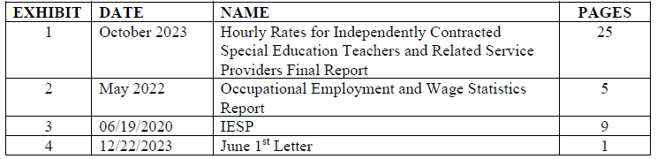

**PARENT EVIDENCE**

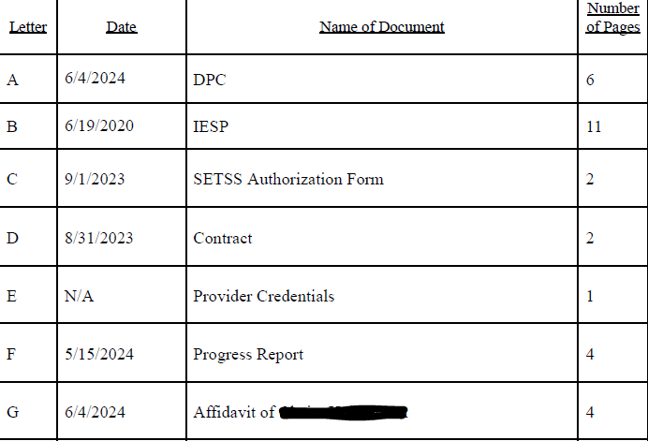

**IHO EVIDENCE**

|  |  |  |  |
| --- | --- | --- | --- |
| **Exhibit** | **Date** | **Name** | **Pages** |
| I | 9/19/2024 | DOE Motion to Dismiss | 26 |

1. As of the date of this decision, a transcript of the Due Process Hearing is unavailable. Once it has been created, the transcript will be incorporated into the case record.
2. Both parties entered the 2020 IESP into the record as an exhibit (P. Ex. B, DOE Ex. 3). For clarity and consistency, I will cite to the Parent’s Exhibit B when referencing the 2020 IESP.
3. *In re Gleason,* 96 NY2d 117, 122 [2001].
4. *Regina Metropolitan Co., LLC v. New York State Division of Housing and Community Renewal,* 35 NY3d 332, 366 [2020], *citing Landgraf v. USI Film Products,* 511 U.S. 244, 365 [1994] [internal quotations omitted].
5. 20 U.S.C. § 1400 (d)(1)(A)
6. 20 U.S.C. § 1401(9)
7. Educ. Law § 3602-c (2)
8. Educ. Law§ 3602-c (2) (b) (l)
9. Educ. Law § 3602-c (2)(a)
10. Educ. Law § 3602-c (2)(b)(1)
11. Educ. Law § 3602-c(2)(a)
12. Educ. Law § 3602-c(2)(b)(1)
13. *See* 8 NYCRR 200.4(e)(7); *see also* *Application of a Child with a Disability*, Appeal No. 08-087.
14. N.L.R.B. v. N.Y. Tele. Co., 930 F2d 1011 (The Court held that when a party is aware of their rights and makes a choice to proceed with a course of conduct contrary to those rights, “a clear and unmistakable waiver may be found.”); Application of a Student with a Disability, 23-033, p.10  (By convening the CSE and developing an IESP for the student, the district is bound by the IESP.); See also, Application of a Student with a Disability, 23-140, p.6, citing, N.L.R.B. v. N.Y. Tele. Co., supra.; and Application of a Bd. of Educ., 18-088, p.8, citing N.L.R.B. v. N.Y. Tele. Co., supra.  (By making the “conscious choice” to convene the CSE after the June 1st deadline and developing an IESP for the student “for whatever reason,” the district waived the defense.).
15. *See*, *e.g.*, *Application of a Student with a Disability*, Appeal No. 21-068.
16. *Id*.
17. *See Davis v. Wappingers Cent. Sch. Dist.*, 431 Fed. App. 12, 14 (2d Cir. 2011).
18. *See Application of a Student with a Disability,* Appeal No. 20-023, citing *Doe v. E. Lyme Bd. of Educ.,* 262 F. Supp. 3d 11, 27 (D.Conn. 2017).
19. *Doe v. East Lyme Bd. Of Educ.*, 790 F.3d 440, 454 (2d Cir. 2015)) (citation omitted).
20. *Florence Cty. Sch. Dist. Four v. Carter,* 510 U.S. 7, 16 (1993).
21. *See Polera v. Bd. of Educ. of Newburgh Enlarged City Sch. Dist*., 288 F.3d 478, 486 (2d Cir. 2002).
22. *Doe v. East Lyme*, 790 F.3d at 454.
23. *See*, *e.g.*, *Application of a Student with a Disability*, Appeal No. 20-115.
24. *See*, *e.g.*, *Foster v. Bd. of Educ. Of the City of Chicago*, 611 Fed. App.’x 874, 878-79 (7th Cir. 2015). (compensatory education includes reimbursement for out-out-pocket educational expenses); *see also P.V. v. Newington Bd. of Educ.*, 546 F.3d 111, 123 (2d Cir. 2008) (compensatory education is an appropriate remedy for a denial of FAPE).
25. *East Lyme Bd. of Educ*., 790 F.3d at 454 (citation omitted).
26. *Frank G.*, 459 F.3d at 364; see *Gagliardo*, 489 F.3d at 115.
27. 20 U.S.C. § 1401(29); Educ. Law § 4401(1); 34 CFR 300.39(a)(1); 8 NYCRR 200.1(ww); *Hardison v. Bd. of Educ. of the Oneonta City Sch. Dist.*, 773 F.3d 372, 386 (2d Cir. 2014).
28. *E.M. v. New York City Dept. of Educ.*, 758 F.3d 442, 451 [2d Cir. 2014]. The Second Circuit has stated, “[t]he IDEA allows a hearing officer to fashion an appropriate remedy, and we have held compensatory education is an available option under the Act to make up for denial of a free and appropriate public education” (*P. ex rel. Mr. & Mrs. P. v. Newington Bd. of Educ.,* 546 F.3d 111, 123 (2d Cir. 2008).
29. *Somoza v. New York City Dept. of Educ.,* 538 F.3d 106, 109 n.2 [2d Cir. 2008].
30. *See, e.g.*, *M.C. ex rel. J.C. v. Cent. Reg’l Sch. Dist.*, 81 F.3d 389 [3d Cir. 1996] (holding that a student denied a FAPE is entitled to compensatory education equal to the period of deprivation).
31. *See, e.g.*, *Reid* *ex rel. Reid* *v. Dist. of Columbia,* 401 F.3d 516, 518, 524 (D.C. Cir. 2005) (requiring a flexible, fact-specific approach in which the award relies “on individual assessments” and is “reasonably calculated to provide the educational benefits that likely would have accrued from special education services the school district should have supplied in the first place.”).
32. *Doe v. East Lyme*, 790 F.3d at 454, 457; *accord* *L.O. ex rel. K.T. v. New York City Dept. of Educ.*, 822 F.3d 95, 125 (2d Cir. 2016); *see also Student X. v. New York City Dept. of Educ.,* 2008 WL 4890440, at *26 (E.D.N.Y 2008) (noting that “the Second Circuit has not articulated a test for determining how [compensatory education] services are calculated,” and awarding compensatory relief equal to the amount of time the student was deprived of services).
33. *Doe. v. East Lyme*, 790 F.3d at 457 (internal citations omitted).